# 查询Where

## Like和concat

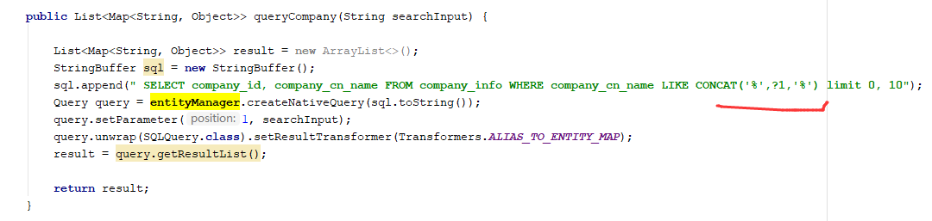

# Spring data不推荐使用

## 默认排序

spring.data.jpa.query ：Cannot use native queries with dynamic sorting and/or pagination in method

https://blog.csdn.net/u010918487/article/details/78341850

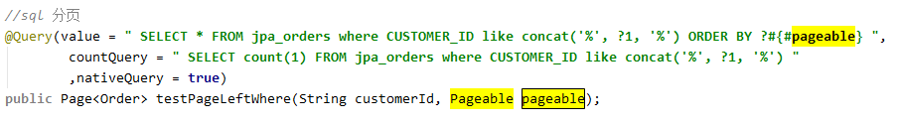

## Sql查询不要用page

因为他会自动去级联查询